**Assignment Documentation: Spring Core + Maven (Library Management System)**

**Exercise 4: Creating and Configuring a Maven Project**

**Scenario:**

You need to set up a new Maven project for the library management application and add Spring dependencies.

**Steps:**

1. **Create a New Maven Project:**
   * Create a new Maven project named **LibraryManagement**.
2. **Add Spring Dependencies in pom.xml:**
   * Include dependencies for Spring Context, Spring AOP, and Spring WebMVC.
3. **Configure Maven Plugins:**
   * Configure the Maven Compiler Plugin for Java version 1.8 in the pom.xml file.

**Step 1: Create a New Maven Project**

**Project Name:** LibraryManagement

* The project was created using an IDE (IntelliJ IDEA )
* Standard Maven project structure was followed:

LibraryManagement/

├── pom.xml

└── src/

└── main/

├── java/

└── resources/

**Screenshot: Project Structure**

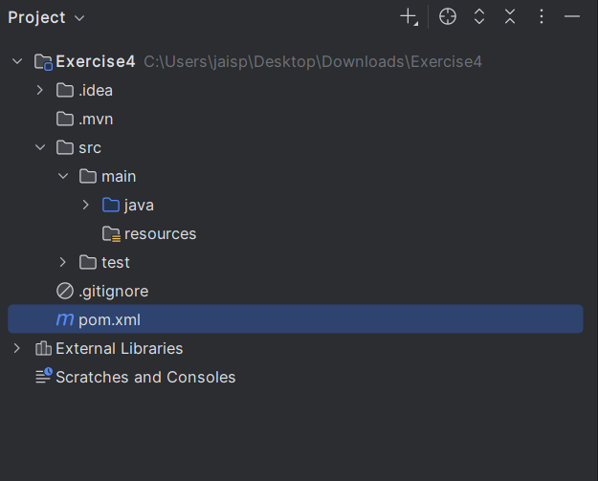

**Step 2: Add Spring Dependencies in pom.xml**

The following dependencies were added to the pom.xml file:

<dependencies>

<!-- Spring Context -->

<dependency>

<groupId>org.springframework</groupId>

<artifactId>spring-context</artifactId>

<version>5.3.30</version>

</dependency>

<!-- Spring AOP -->

<dependency>

<groupId>org.springframework</groupId>

<artifactId>spring-aop</artifactId>

<version>5.3.30</version>

</dependency>

<!-- Spring WebMVC -->

<dependency>

<groupId>org.springframework</groupId>

<artifactId>spring-webmvc</artifactId>

<version>5.3.30</version>

</dependency>

</dependencies>

**Screenshot: pom.xml with Dependencies**

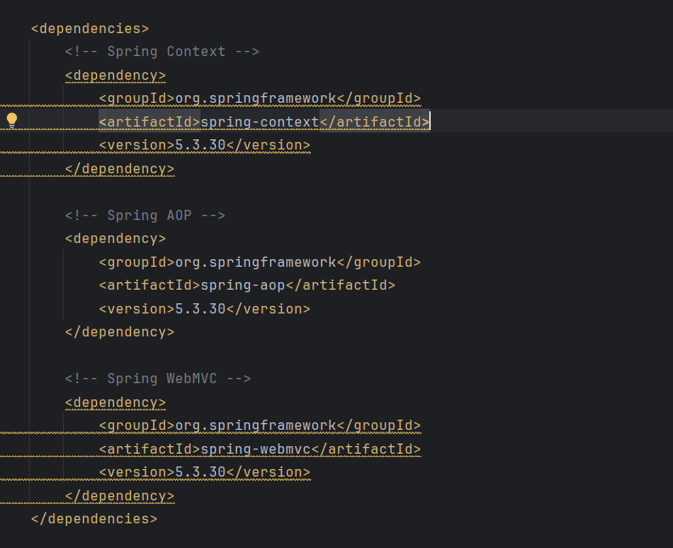

**Step 3: Configure Maven Compiler Plugin**

Configured to compile Java source code using Java 1.8:

<build>

<plugins>

<plugin>

<groupId>org.apache.maven.plugins</groupId>

<artifactId>maven-compiler-plugin</artifactId>

<version>3.8.1</version>

<configuration>

<source>1.8</source>

<target>1.8</target>

</configuration>

</plugin>

</plugins>

</build>

**Screenshot: Maven Compiler Plugin Configuration**

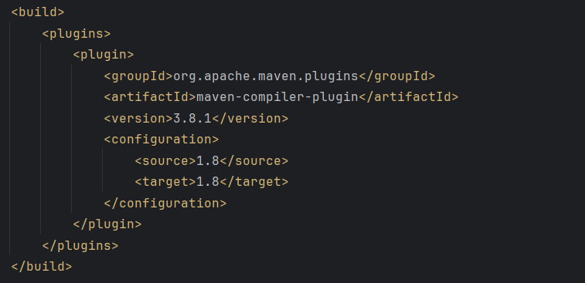

**Conclusion**

All requirements for Exercise 4 have been successfully implemented:

* Maven project created with standard directory layout
* Spring Context, AOP, and WebMVC dependencies added
* Compiler plugin configured for Java 1.8 compliance